**Power BI Assignment 2**

1. **Explain the advantages of Natural Queries in PowerBi with an example?**

**Answer:** Power BI Natural Language Query (NLQ) is a functionality offered by Power BI that enables users to ask questions in simple, plain English to get an understanding of your dataset. Power BI uses these queries to provide answers in the form of data visualizations, data tables, graphics, or other formats that help users quickly create data visualization. This feature is helpful for Power BI users to explore and get insights about their datasets and create data visualization without requiring any technical know-how to author those reports. The best part of this is you can use the Power BI Natural Language Query with all versions of Power BI, including Power BI Desktop, Power BI Service, and the Power BI mobile app.

Power BI NLQ offers a lot of benefits that include:

* Easy access to data visualization: You can create data visualization without having to acquire technical expertise
* Quick data insights: You can get faster data insights without using any complex DAX queries or performing any calculations
* Easy to write queries: You can write simple, plain English questions to display data visualization with the option of adding filters

Example:

**Step 1:** Open the Power BI Service portal in your browser, i.e., Microsoft Fabric (powerbi.com)

**Step 2:** Click on **My workspace** from the left navigation pane.

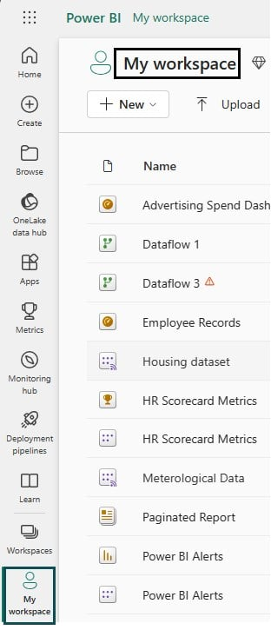

It will display all the Power BI components you have published to Power BI Service.

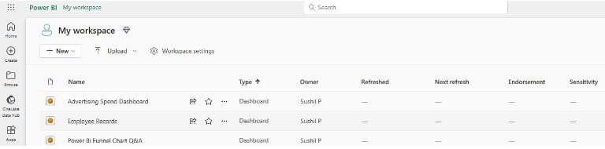

**Step 3:** Click on a dashboard link. It will take you to the dashboard window.

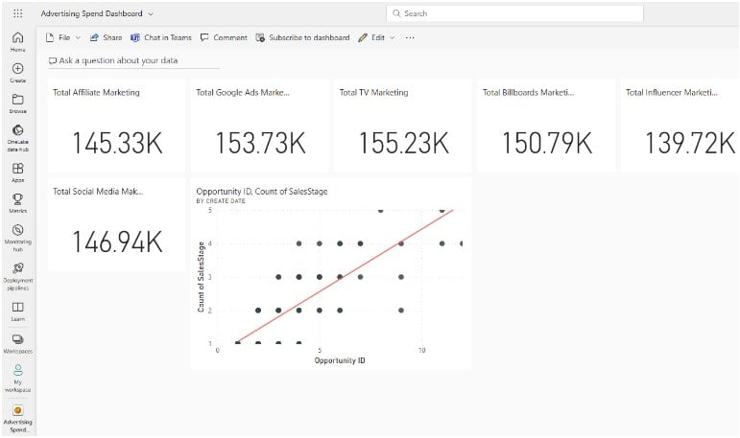

**Step 4:** On the dashboard screen, click on **Ask a question about your data** which is available at the top of your screen.

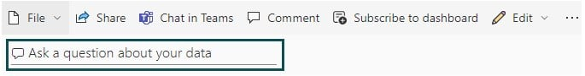

**Step 5:** Power BI Service will navigate you to a Q&A page along with a list of suggested questions based on your dataset.

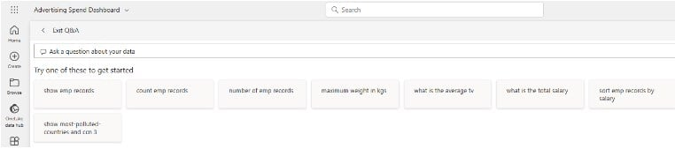

**Step 6:** You can select any of the suggested options to add them to the question box and refine your question to search for a specific query.

When you write questions using the Natural Language Query, Power BI provides autocomplete suggestions, visualization, restatements, and feedback that you can leverage to refine your queries.

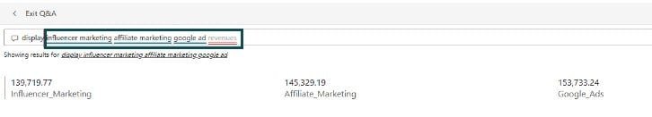

You will notice that there are texts highlighted in blue and red color. The Power BI suggested terms are underlined in blue i.e. influencer marketing text in this case. Similarly, the text that Power BI fails to understand is highlighted in red color i.e. revenues.

**Step 7:** Use the **Pin visual** option to pin the visual to the dashboard.

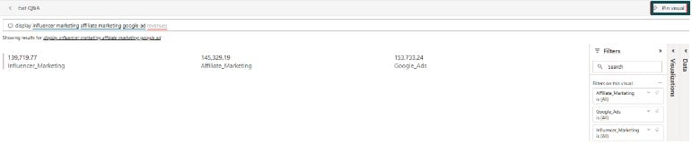

**Step 8:** Select the existing dashboard option to pin the visual to the dashboard and click on Pin.

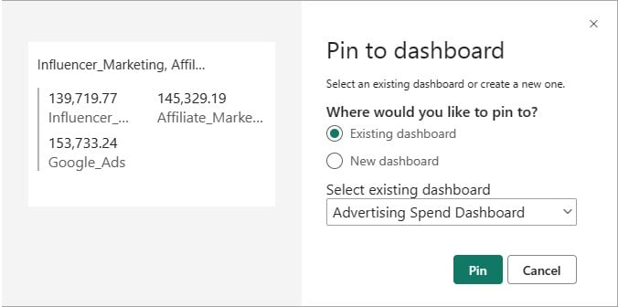

This will pin the visual to the dashboard.

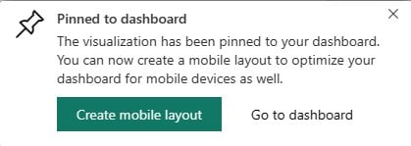

**Step 9:** Click on the Exit Q&A.

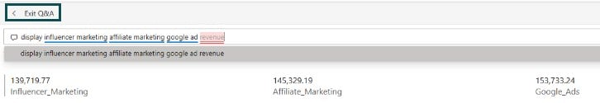

You will see the pinned visual in the dashboard.

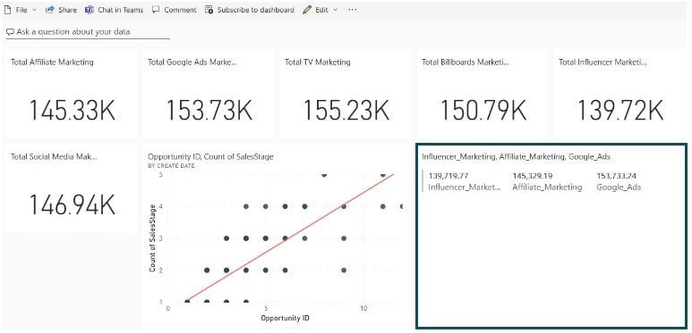

1. **Explain Web Front End(WFE) cluster from Power BI Service Architecture?**

**Answer:** The Power BI service is built on Azure, Microsoft's cloud computing infrastructure and platform. The architecture of the Power BI service is based on two clusters:

The Web Front End (WFE) cluster. The WFE cluster manages the initial connection and authentication to the Power BI service.

The **WFE** cluster uses Microsoft Entra ID to authenticate clients, and provide tokens for subsequent client connections to the Power BI service. Power BI uses the **Azure Traffic Manager** (Traffic Manager) to direct user traffic to the nearest datacenter. Traffic Manager directs requests using the DNS record of the client attempting to connect, authenticate, and to download static content and files. Power BI uses the **Azure Content Delivery Network** (CDN) to efficiently distribute the necessary static content and files to users based on geographical locale.

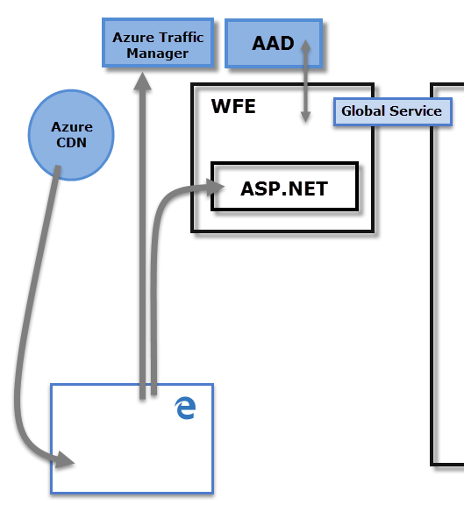

1. **Explain Back End cluster from Power BI Service Architecture?**

**Answer:** The Power BI service is built on **Azure**, Microsoft's cloud computing infrastructure and platform. The architecture of the Power BI service is based on two clusters:

The **Back-End** cluster. Once authenticated, the **Back-End** handles all subsequent user interactions. Power BI uses Microsoft Entra ID to store and manage user identities. Microsoft Entra ID also manages data storage and metadata using Azure BLOB and Azure SQL Database, respectively.

The **Back-End** cluster determines how authenticated clients interact with the Power BI service. The **Back-End** cluster manages visualizations, user dashboards, semantic models, reports, data storage, data connections, data refresh, and other aspects of interacting with the Power BI service. The **Gateway Role** acts as a gateway between user requests and the Power BI service. Users don't interact directly with any roles other than the **Gateway Role**. **Azure API Management** eventually handles the **Gateway Role**.

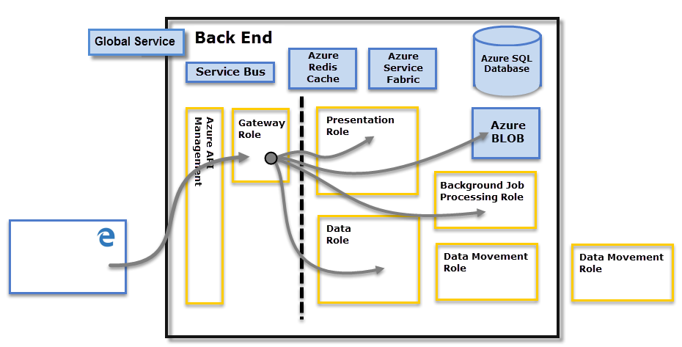

1. **What ASP.NET component does in Power BI Service Architecture?**

**Answer:**

We'll get started by creating a new ASP.NET Core 5 MVC Web App in Visual Studio 2019 as seen in **Figure 1**.

**[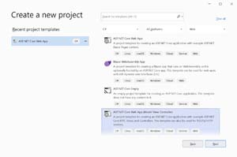](https://visualstudiomagazine.com/Articles/2021/09/23/~/media/ECG/visualstudiomagazine/Images/2021/09/powerbi1.ashx)**

***1:*** Create New ASP.NET Core 5 MVC Web App

After that give a name to the web application as seen in **Figure 2**.

**[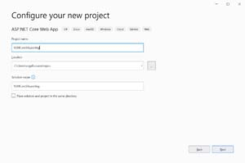](https://visualstudiomagazine.com/Articles/2021/09/23/~/media/ECG/visualstudiomagazine/Images/2021/09/powerbi2.ashx)**

***2:*** Naming Your ASP.NET Core 5 App

On the next dialog select **.NET 5** as your target framework as seen in **Figure 3**.

**[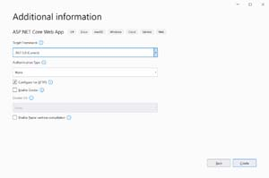](https://visualstudiomagazine.com/Articles/2021/09/23/~/media/ECG/visualstudiomagazine/Images/2021/09/powerbi3.ashx)**

***3:*** Select .NET 5 Framework

Next click the **Create** button and you will have a new ASP.NET 5 Core web app that has a Razor page named Index.

Now that we have our web app created, let's get our Power BI report created. In order to create a Power BI report you'll need to [**create a Power BI account**](https://powerbi.microsoft.com/en-us/getting-started-with-power-bi/). I'll be using a new trial account for our demo report. Note that as of now you need a work email address to sign up for a Power BI account.

You should now see the Power BI dashboard where we'll create a new report as seen in **Figure 4**.

**[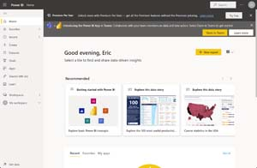](https://visualstudiomagazine.com/Articles/2021/09/23/~/media/ECG/visualstudiomagazine/Images/2021/09/powerbi4.ashx)**

**4*:*** Power BI Dashboard

Click on the **New report** button. You should now see the screen in **Figure 5** where you can pick your data set. Pick the **Paste or manually enter data** option.

**[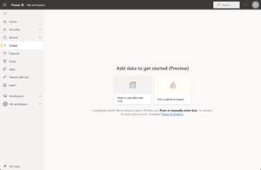](https://visualstudiomagazine.com/Articles/2021/09/23/~/media/ECG/visualstudiomagazine/Images/2021/09/powerbi5.ashx)**

***5:*** Pick a Dataset for Our Report

Now we'll enter some test report data in a Customers table as seen in **Figure 6**.

**[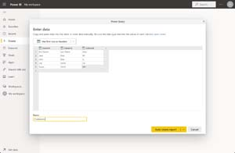](https://visualstudiomagazine.com/Articles/2021/09/23/~/media/ECG/visualstudiomagazine/Images/2021/09/powerbi6.ashx)**

***6:*** Creating Test Report Data

Then click on the **Auto create report** button. Power BI will come up with some auto generated reports that aren't very useful, so we'll go to the **Datasets** tab and select our **Customers** dataset as seen in **Figure 7**.

**[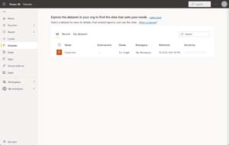](https://visualstudiomagazine.com/Articles/2021/09/23/~/media/ECG/visualstudiomagazine/Images/2021/09/powerbi7.ashx)**

***7:*** Customers Dataset

On the next page select the **Create from scratch** option that will bring you to a create a report screen. Enter the settings seen in **Figure 8**.

**[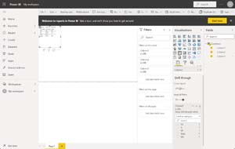](https://visualstudiomagazine.com/Articles/2021/09/23/~/media/ECG/visualstudiomagazine/Images/2021/09/powerbi8.ashx)**

***8:*** Creating our Report

Our test report just displays all of our data in a table with a drill through for the third State column. We'll now save our report through **File->Save report** and give our report a name of "Customers" as seen in **Figure 9**.

**[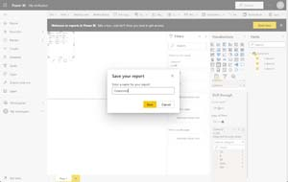](https://visualstudiomagazine.com/Articles/2021/09/23/~/media/ECG/visualstudiomagazine/Images/2021/09/powerbi9.ashx)**

***9:*** Saving Our Report

We are now going to publish our report to the web through **File->Embed report-> Publish to web** as seen in **Figure 10**.

**[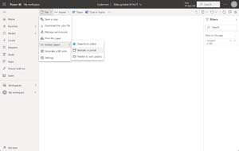](https://visualstudiomagazine.com/Articles/2021/09/23/~/media/ECG/visualstudiomagazine/Images/2021/09/powerbi10.ashx)**

***10:*** Publish Report Embed

Your administrator will have to enable this feature in order to successfully publish your report to the web. If this is your own Power BI account, you can also start a free 60-day trial to enable this feature. You will now see a modal with a link to your report and iframe code to embed the report in your web app. Copy the iframe code now as seen in **Figure 11**.

**[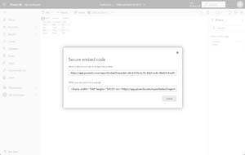](https://visualstudiomagazine.com/Articles/2021/09/23/~/media/ECG/visualstudiomagazine/Images/2021/09/powerbi11.ashx)**

11.Power BI Embed Options

Now it is time to embed our report in our ASP.NET 5 Web App. Open up the Index.cshtml file and put in this markup:

@{

ViewData["Title"] = "Home Page";

}

<div class="text-center">

<h2>Customers Report</h2>

<iframe width="1140" height="541.25" src="https://app.powerbi.com/reportEmbed?reportId=d6c4372b-6c7b-48a5-ac4c-8bd20c9aa0f4&autoAuth=true&ctid=8519dfd5-6e3f-43b7-a4ce-f7c5afbe8ce4&config=eyJjbHVzdGVyVXJsIjoiaHR0cHM6Ly93YWJpLXdlc3QtdXMtZC1wcmltYXJ5LXJlZGlyZWN0LmFuYWx5c2lzLndpbmRvd3MubmV0LyJ9" frameborder="0" allowFullScreen="true"></iframe>

</div>

Replace the <iframe> tag with your custom Power BI Report. You can now run your web app and interact with your report as seen in **Figure 12**.

**[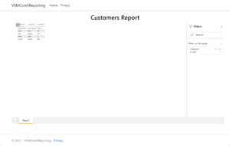](https://visualstudiomagazine.com/Articles/2021/09/23/~/media/ECG/visualstudiomagazine/Images/2021/09/powerbi12.ashx)**

1. **Compare Microsoft Excel and PowerBi Desktop on the following features**

**Answer:**

|  |  |  |
| --- | --- | --- |
| **Features** | **Power BI** | **Excel** |
| Tabular Reports | It creates relatively limited tabular reports. | It’s ideal for making tabular reports. |
| Duplicate Tables | Can’t display duplicated tables | Allows you to display duplicated tables |
| Reports | More visually appealing, customized, appealing, and interactive reporting. | Reports are simpler and less appealing than those in Power BI. |
| Crossed Filters | Supports powerful chart cross-filtering features. | There is no advanced graphics cross-filtering. |
| Charts and Visuals | Dashboards, alarms, and KPIs work best. Includes richer graphics than Excel and allows for visual data analysis. | It contains the most powerful and cutting-edge charting tools, however it isn’t compatible with data models. |
| Automatic Updates | Data is automatically updated. | Data is not automatically updated. |
| Availability | Repots can be worked on by a huge number of people, regardless of their expertise. | The number of users who can see a report is limited. |
| Analytics | Power BI has fewer data analysis possibilities. | Excel has more advanced analytical capabilities. |
| Data Model | Ideal for quickly creating complex data models. | Works with simple and structured data models. |
| Separate Tables | Separate tables can be linked together easily. | Connecting various tables is tough. |
| Tools | It is a more complex version of the data analysis tool, with more options for working with data. | It’s a standard spreadsheet tool with a lot of options. |
| Collaborative Work | Power BI makes it simple to share data and reports. | Sharing documents and working with others is complex. |
| Big Data | Allows working with significantly bigger data sets. | Can only handle a certain amount of info. |
| Dashboards | More advanced features for creating custom dashboards. | Users have limited features for creating dashboards. |
| Processing | Faster processing. | Slower processing. |
| Utility | Dashboards can be created and shared, as well as advanced data visualizations. | Typically, it is used to arrange data, execute calculations, and build more complex tabular reports. |
| Data Model Language | DAX language | MDX language |
| Connectivity | Data can be extracted from any virtual platform, software, or application. | Connectivity to other apps and systems is limited. |
| Price | It has [a free version](https://dynamics.folio3.com/blog/difference-between-power-bi-pro-vs-free-vs-premium/) and a payment version. | Payment Tool. |
| Usability | Easy to use compared to Excel | More difficult to use than Power BI |

1. **List 20 data sources supported by Power Bi desktop.**

**Answer:** The **Database** category provides the following data connections:

* SQL Server database
* Access database
* SQL Server Analysis Services database
* Oracle database
* IBM Db2 database
* IBM Informix database (Beta)
* IBM Netezza
* MySQL database
* PostgreSQL database
* Sybase database
* Teradata database
* SAP HANA database
* SAP Business Warehouse Application Server
* SAP Business Warehouse Message Server
* Amazon Redshift
* Impala
* Google BigQuery
* Google BigQuery (Microsoft Entra ID)(Beta)
* Vertica
* Snowflake